THE MOST INTERESTING SIGHTS OF PRAGUE
PRACOVNÍ LIST Jméno:
1. Write down about these sights:
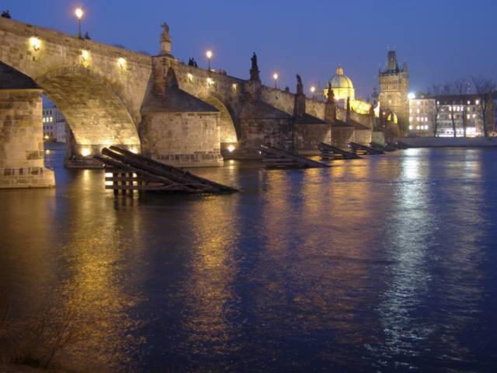
____________________________________________________________________________________________________________________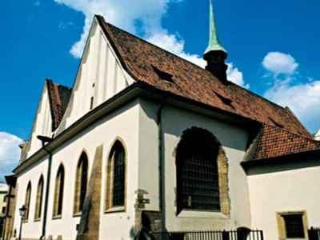___________________________________________________________________________________________________________________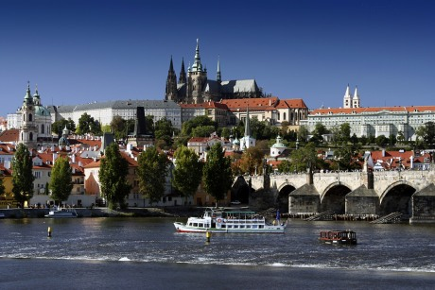
_______________________________________________________________________________________
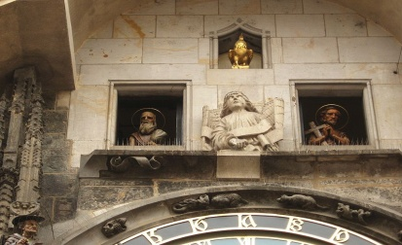
_______________________________________________________________________________________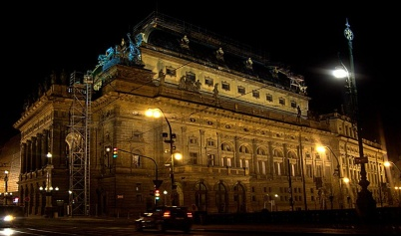
_______________________________________________________________________________________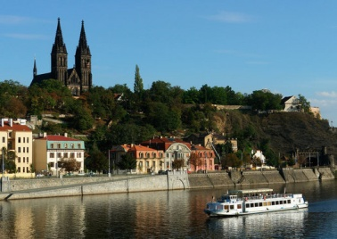
__________________________________________________________

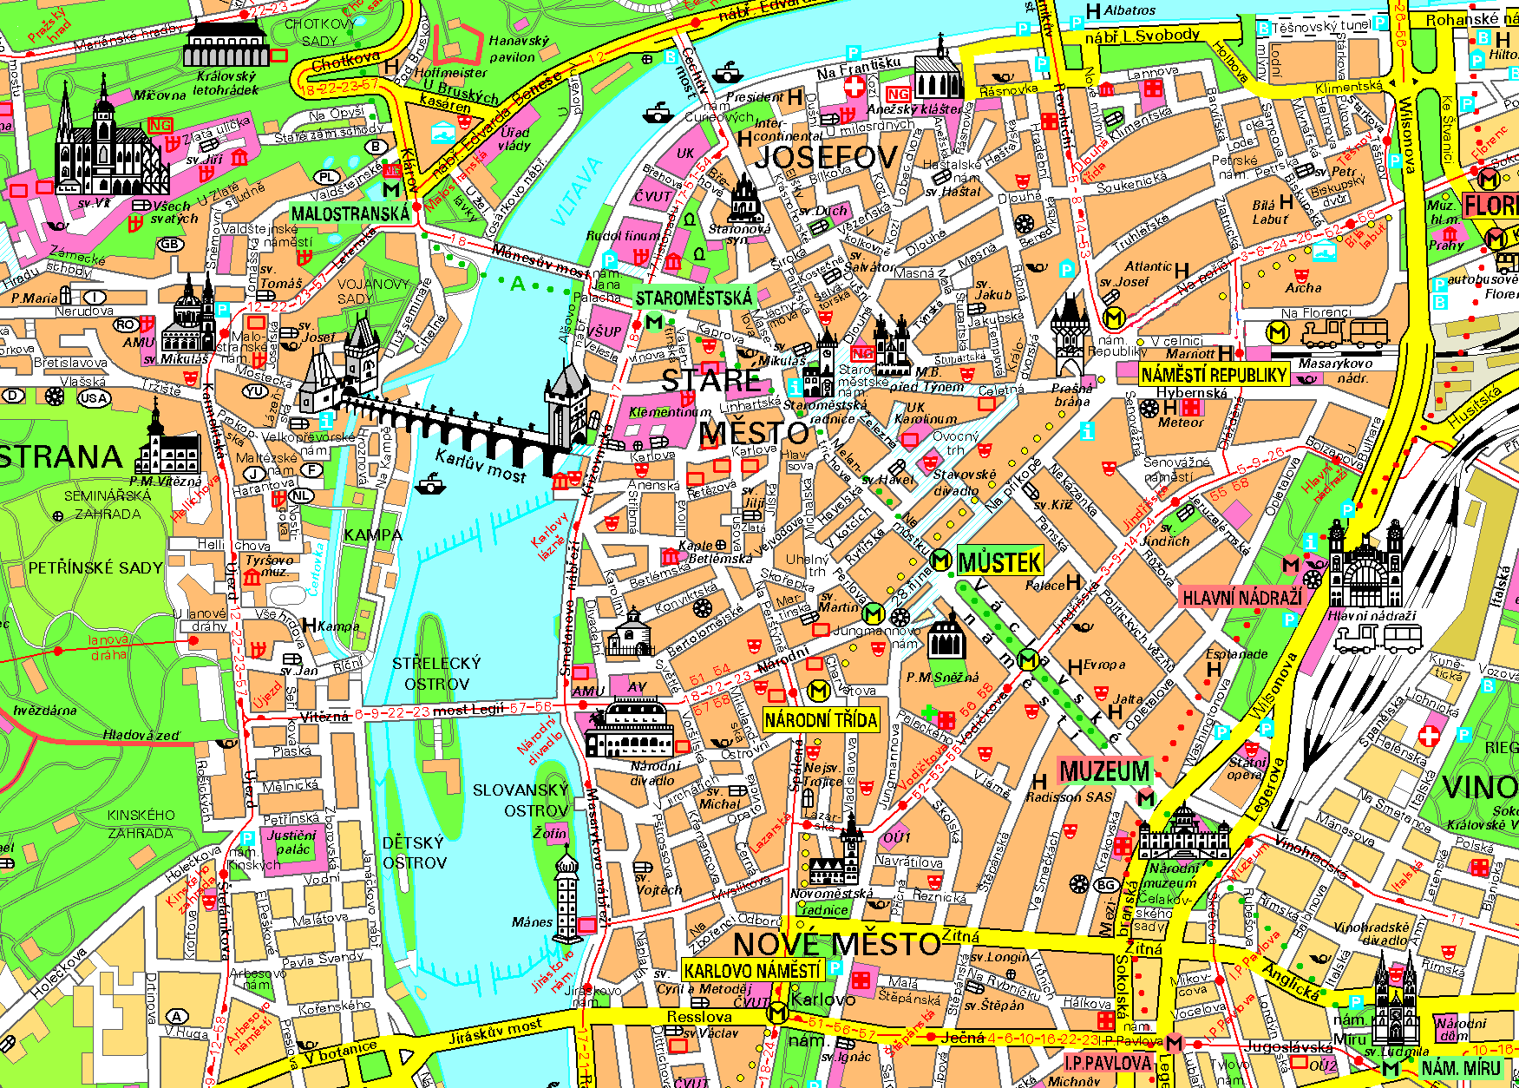
2. Circle the famous sights.
3. Describe, how to get from:
CHARLES BRIDGE to SQUARE OF THE REPUBLIC
___________________________________________________________________________________________________________________________________________________________________________________________________
PRAGUE CASTLE to NATIONAL THEATRE
__________________________________________________________________________________________________________________________________

