The Grand Canyon- pracovní list
jméno:
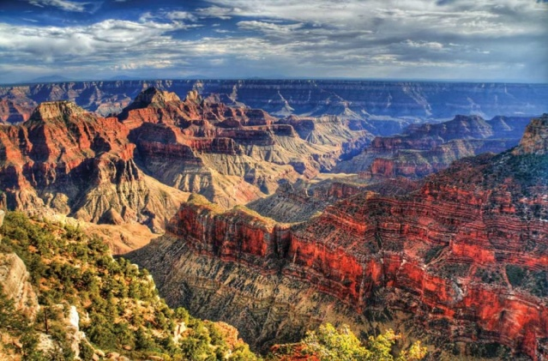
1. Read the text and translate the underlined expressions:
Grand Canyon is the best known canyon all over the world ..................................................... It is created …………………………………………………….by the Colorado River in northern Arizona in the United States. The canyon was modeled by the flow……………………………………………. of the Colorado River, it is nearly 446 km long and 500 meters to 29 kilometers wide. The maximum depth of the canyon is 1600 meters! The river took away ……………………………………………………..the layer after layer of sediment to uncover …………………………………..the Colorado Plateau.
2. Answer the questions, then practise as a dialogue:
How is the Grand Canyon created?
_______________________________________________________________________________________
How long and wide is it?
__________________________________________________________
How deep is it?
_____________________________
Where can You find it?
_____________________________
3. Listen to the video sequence up to 6 minutes twice, then answer:
WHAT DID DR. STEVE AUSTIN FIND IN GRAND CANYON?
__________________________________________________________
WHAT COLOUR IS THE LIMESTONE?
_____________________________
HOW LONG ARE THE FOSSILS?
_____________________________
WHAT SHAPE ARE THEY?
_____________________________
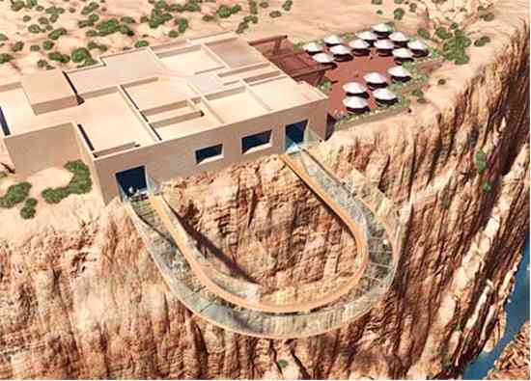
4. Expressing feelings:
How would You feel during walking along the Skywalk? Write down briefly:
_________________________________________________________________________________________________________________________________________________