

FLORIDA – pracovní list žáka

jméno:

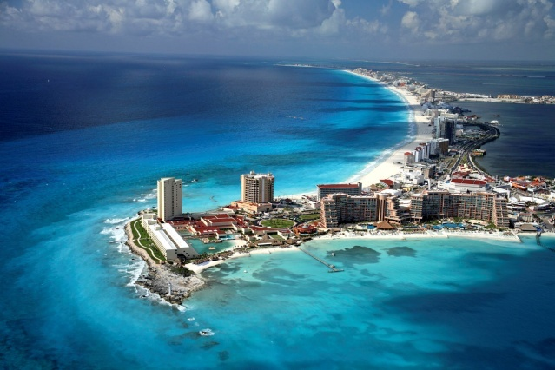

**1. Read the text properly and highlight the adjectives with green felt-tip.**

**The name "Florida" is a Spanish adjective which means "flowery". The symbol of this state is the pelican. Spanish sailors discovered Florida during the Easter holidays, which are called in Spanish "Pascua Florida". More than 18 million people live in Florida, which is 13% more than in 2000. Florida is the second fastest growing state in the U.S.. The capital of Florida is Tallahassee, but the most famous town is Miami. This city is dominated by tall skyscrapers and many nightclubs.**

**2. Make the questions about highlighted adjectives.**

ZEPTEJ SE NA PŮVOD SLOVA FLORIDA:_____________________

__________________________________________________________

ZEPTEJ SE, ODKUD BYLI OBJEVITELÉ FLORIDY:___________________________________________________

ZEPTEJ SE, JAKÝ JE DRUHÝ NEJRYCHLEJI ROSTOUCÍ STÁT V U.S.:

__________________________________________________________

ZAPTEJ SE NA NEJZNÁMĚJŠÍ LETOVISKO NA FLORIDĚ:

__________________________________________________________

CO JE DOMINANTAMI MĚSTA?

__________________________________________________________

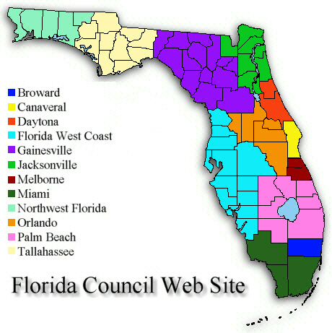

**3. C:\Users\mecholupy\AppData\Local\Microsoft\Windows\Temporary Internet Files\Content.IE5\A0S664HK\MC900413596[1].wmf Work with this map. Write sentences, describing the Florida districts, using the World sites.**

**Ex:** THE NORTHERN DISTRICTS ARE JACKSONVILLE AND GAINESVILLE.

_______________________________________________________________________________________________________________________________________________________________________________________________________________________________________________________________________________________________________________________________

GOOD JOB!

**4. Write down the names of famous places in Florida:**

