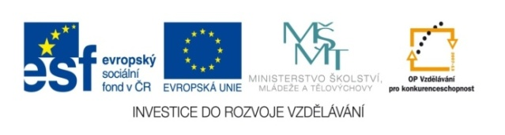

10. In the swimming pool

PRACOVNÍ LIST ŽÁKA Jméno:

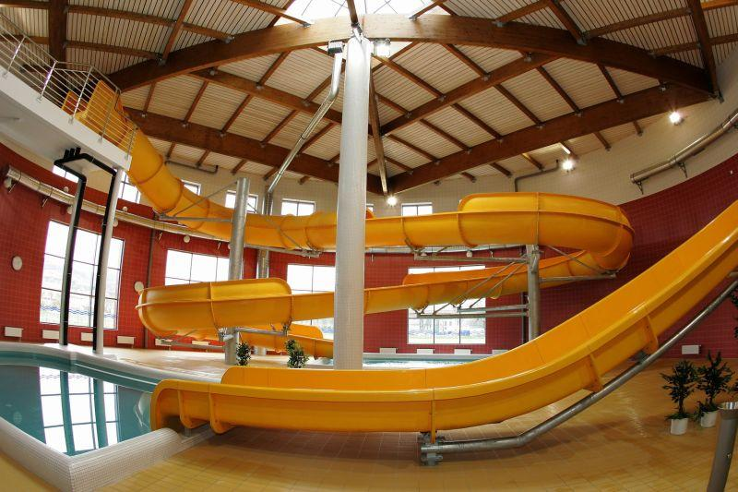

**1. Describe this picture, using dictionary if necessary.**

__________________________________________________________________________________________________________________________________________________________________________

**2. Would You like to go on waterrides (tobogans)? Try to suggest Your plan for Your friend to join You:**

__________________________________________________________________________________________________________________________________________________________________________**3. Draw a body and connect with these parts:**

**CHEST ARM NECK NOSE HAND ELBOW SHOULDER FINGER LEG KNEE STOMACH BOTTOM HIP ANKLE TOE WRIST**

**4. Water activities.**

**Describe exactly, what these people are doing at the moment.**

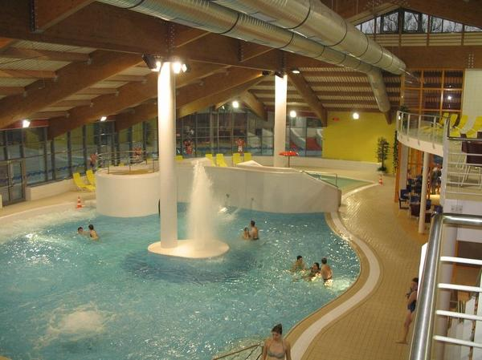

____________________________________________________________________________________________________________________________________________________________________________________________________________**5.In the whirlpool bath.**

**Divide the text by the speech bubbles to Jan, Marie and Hans.**

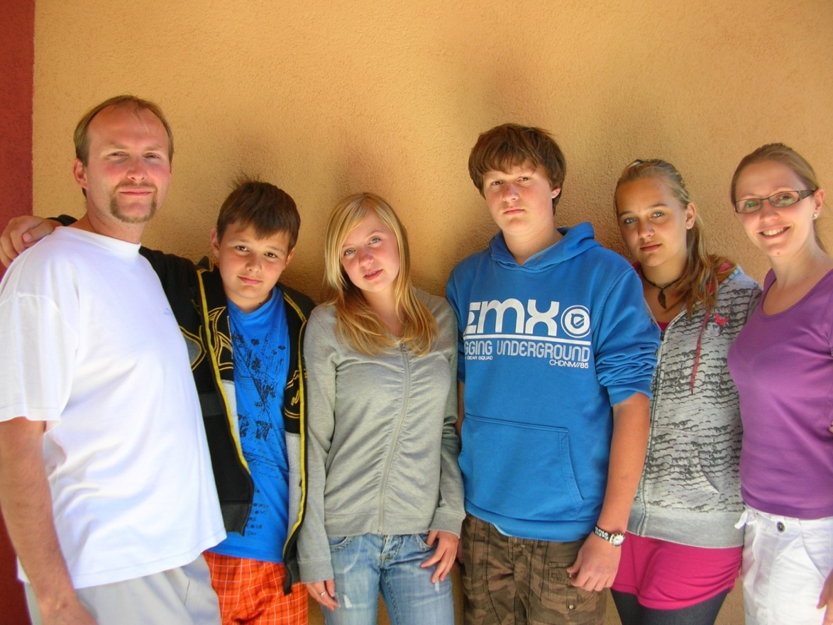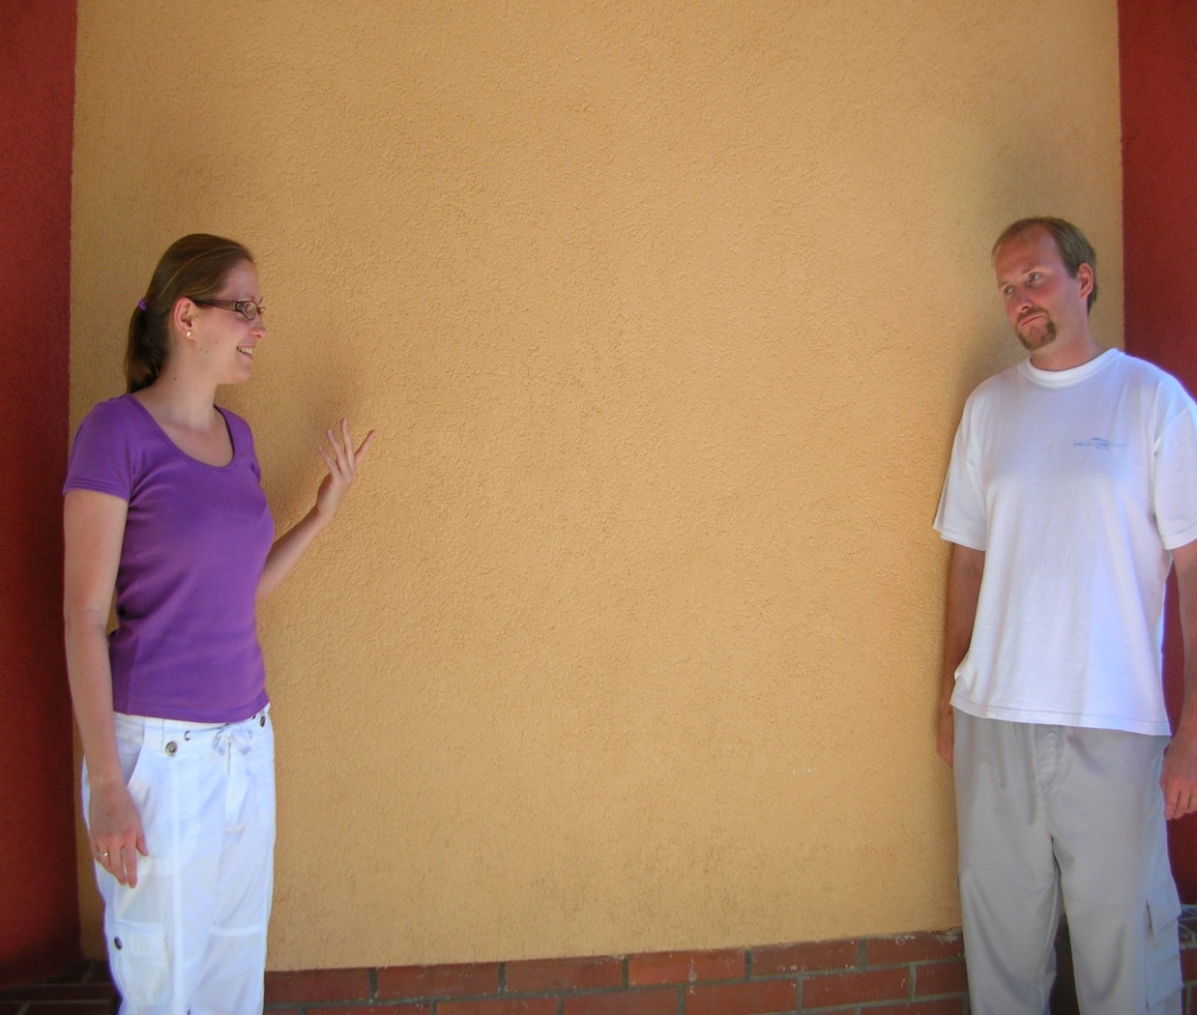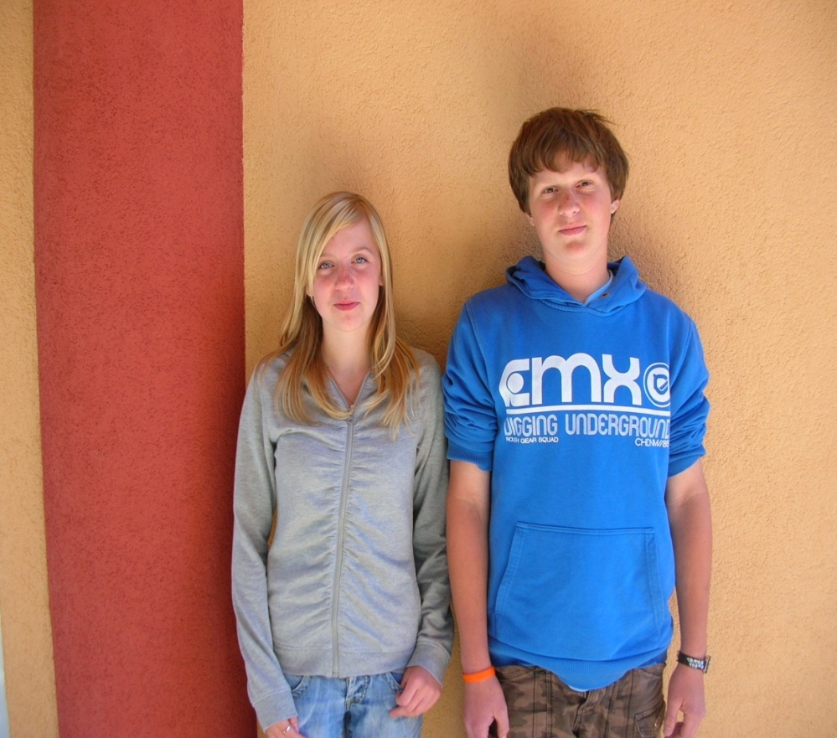

It´s perfect massage for all the body- back, legs, neck- very comfortable.

Some nozzles flow hot, some cold water, it´s very special!

Oh, my legs and arms are vibrating! I can´t hold it!

Hans, it´s O.K., You will adapt on it.

**6. C:\Users\mecholupy\AppData\Local\Microsoft\Windows\Temporary Internet Files\Content.IE5\6YLUN3E9\MC900283397[1].wmf Grammar- read properly**

**Suggestions-návrhy**

* **We use to offer, suggest to somebody our idea, plan which helps to change his opinion or encourage him to do something.**
* **Používáme k nabídce našeho nápadu, plánu někomu dalšímu, což může vést ke změně jeho názoru nebo dodání odvahy něco udělat.**
* **We use phrases starting with:**
* **Shall we…? Let´s…….. Why don´t we……..?**
* **Focusing on positive feelings: It´s super, relaxive, absolutely perfect, brilliant, wonderful, marvellous!**

**7. Swimming styles.**

**Try to show these styles or explain without using Czech:**

* Freestyle
* Backstroke
* Breaststroke
* Butterfly 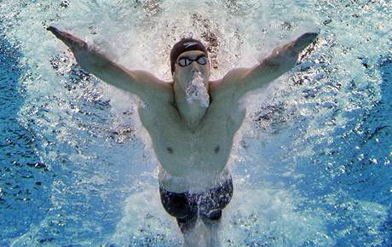

**Swimming is one of the healthiest sports. Try it!**